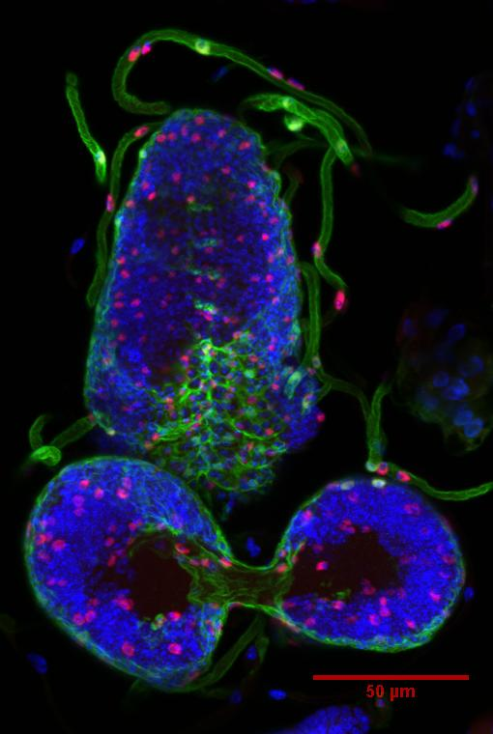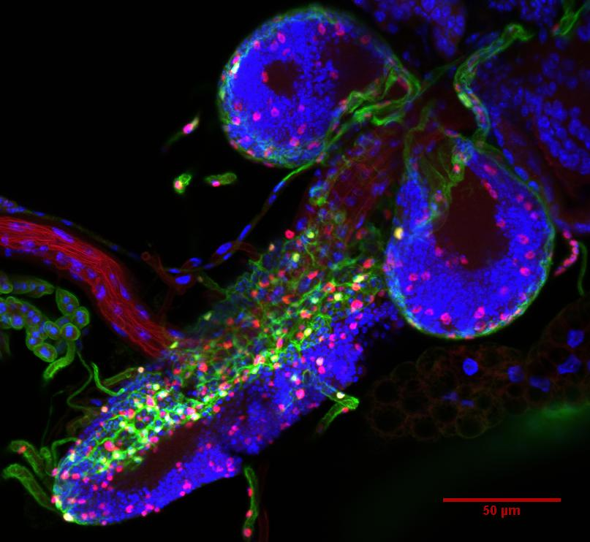
1st instar larvae
2nd instar larvae

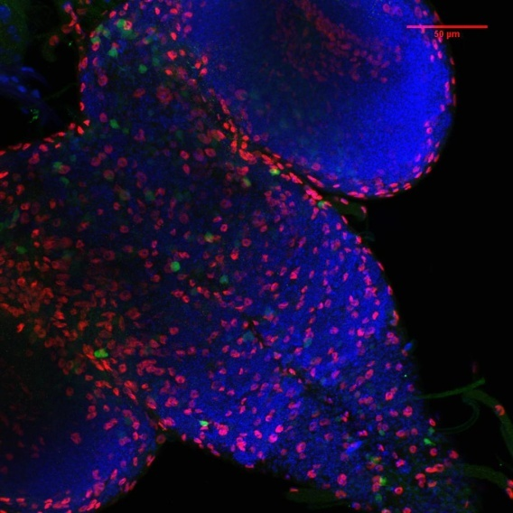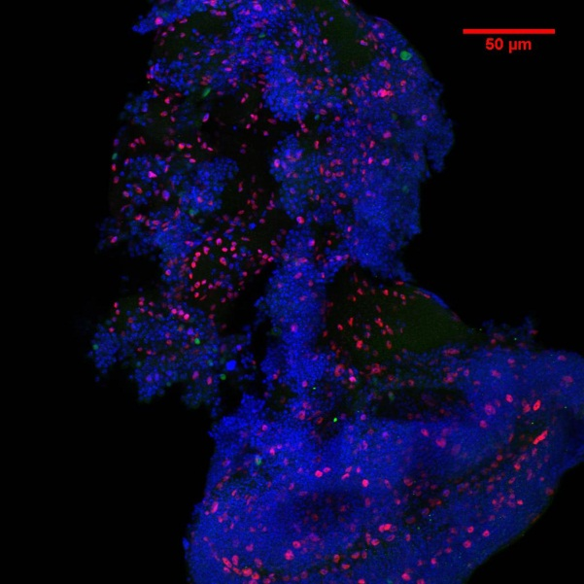
Adult
3rd instar larvae

Figure 2.4. The 17A-GAL4 driver was crossed to the UAS-GFP reporter fly line and the resulting progeny were assayed for expression of GFP (green), Repo (red), and DAPI (blue). Z-projections of 5 to 12 slices; scale bar=50µm.

publications, showing that the death of Eaat1 cells is embryonic lethal to the entire organism . As an internal control, the second cross shows that flies without the UAS-reaper construct are viable in this background.
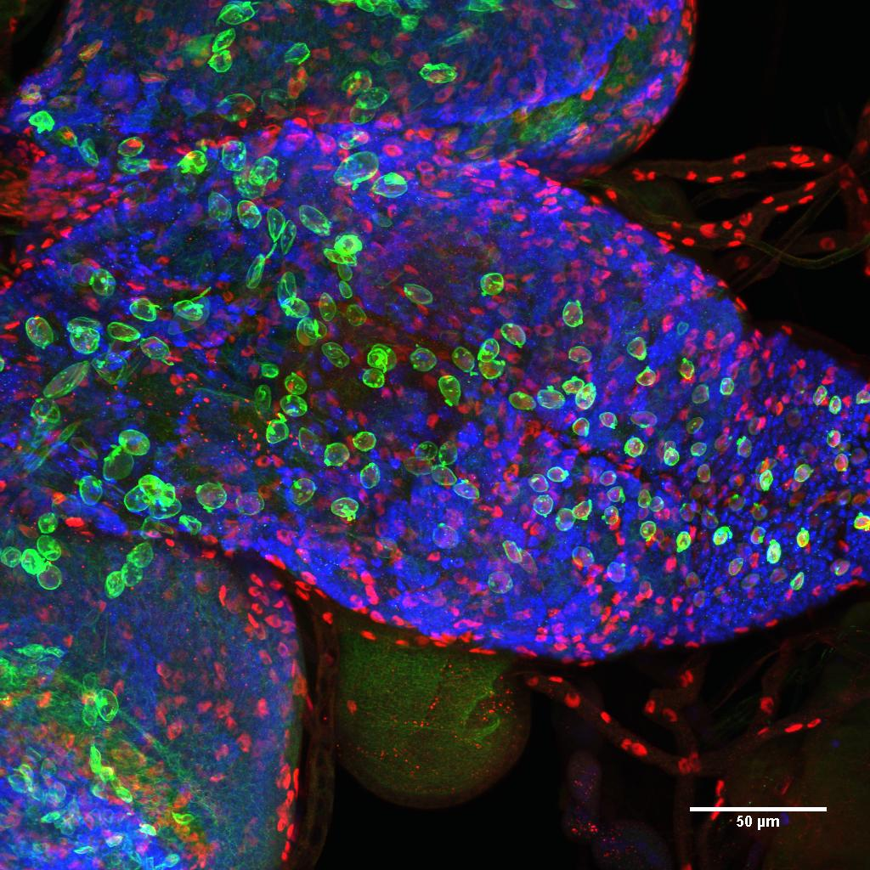
Red = Repo (glia)
Green = NICD
Blue = Elav (neurons)
70% NICD+ Repo+
0% NICD+ Elav+
30% NICD+ Repo- Elav-

Figure 2.5. Eaat1GAL4>UAS-NICD 3rd instar brains stained for Repo, NICD, Elav then analyzed with confocal microscopy. Shown is a z-projection of 29 slices. Scale bar = 50 microns.
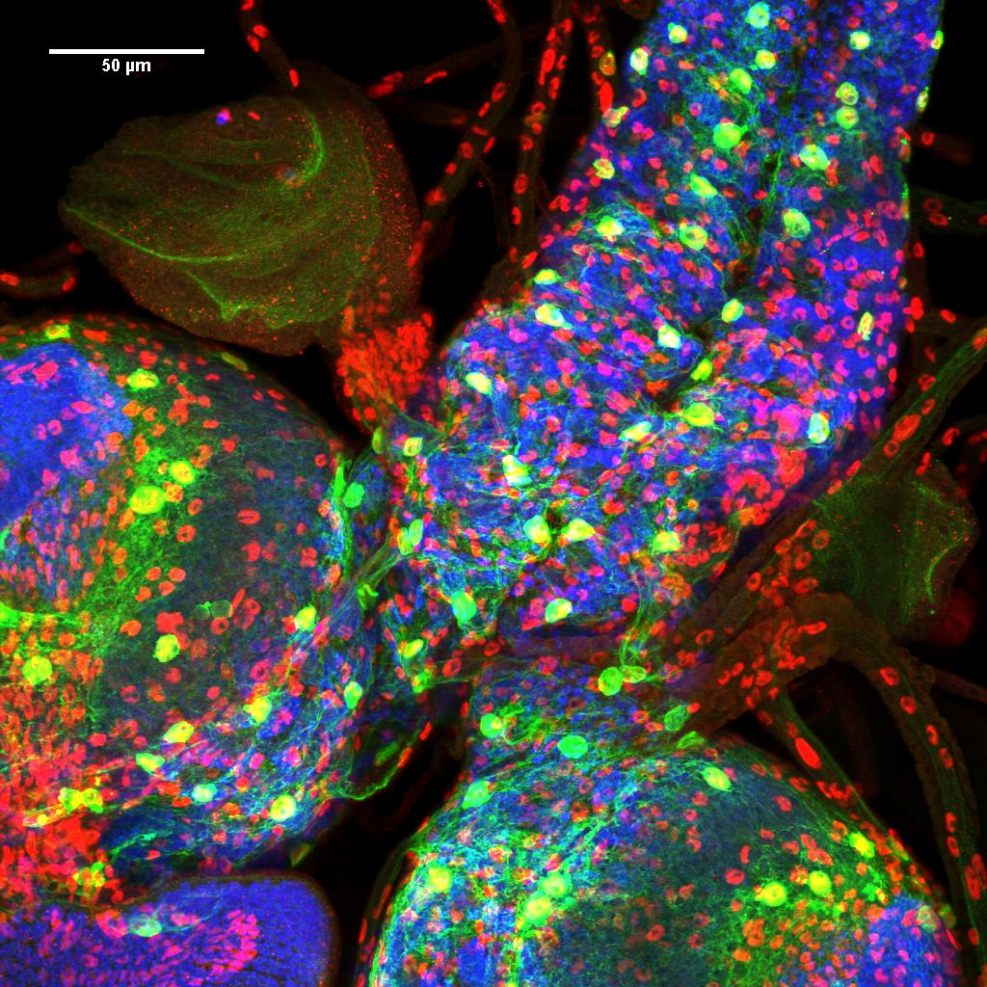
90% NICD+ Repo+
6% NICD+ Elav+
4% NICD+ Repo- Elav-
Red = Repo (glia)
Green = NICD
Blue = Elav (neurons)

Figure 2.6. 17AGAL4>UAS-NICD 3rd instar brains stained for Repo, NICD, Elav then analyzed with confocal microscopy. Shown is a z-projection of 27 slices. Scale bar = 50 microns.
Figure 2.7. Results of crossing flies with the Eaat1-driven GAL4 transcription factor to the UAS-reaper flies.
To ask more questions about the characterization of NICD-mediated hypoxic survival, a double balanced fly line containing the Eaat1-GAL4 construct as well as UAS-NICD was derived following the crosses in Figure 2.7. This line
Figure 2.8. Derivation of a Drosophila line stably over-expressing NICD under the control of Eaat1-GAL4 driver.
that stably over-expresses NICD can then be crossed to other UAS lines, allowing the testing of other pathways that interact with Notch. Additionally, this line can be used to address other questions.
To further characterize the over-expression of NICD, the question of the precise subcellular localization arose. To address this question, the EN line was crossed to lines containing inserts of GFP in particular proteins (Quinones-Coello et al., 2007). The first image of Figure 2.9 is that of GFP expressed in protein TER94, which in known to localize with the Golgi, does not co-localize with NICD over-expression. Also in Figure 2.8, GFP inserted into the protein calrecticulin, which is known to localize to the endoplasmic recticulum, does co-localize with NICD over-expression. Thus, the confocal images show that the over-expressed NICD co-localizes not with the endoplasmic reticulum or Golgi, but with the nuclear envelope protein, Lamin.
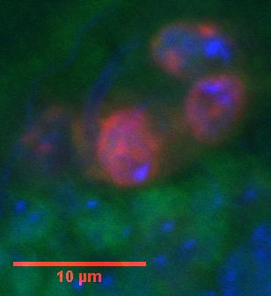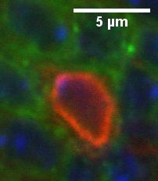
EN X TER94-GFP
Red = NICD
Blue = DAPI
Green = Golgi
EN X calrecticulin-GFP
Red = NICD
Blue = DAPI
Green = ER
EN X lamin-GFP
Red = NICD
Blue = DAPI
Green = Lamin
5 µm
A
B
C
B

Figure 2.9. Sub-cellular localization of NICD over-expression in glia. (A) Shows the antibody staining of Golgi with the over-expression of NICD. (B) The results of crossing the EN line to a line expressing GFP in the pattern of Calrecticulin. (C) The yellow color indicates co-localization of NICD over-expression with Lamin.
Finally, are traditional Notch targets genes are up-regulated by the over-expression of NICD? This can be approached by crossing the EN line to a Notch transcriptional reporter gene, concatamerized Suppressor of Hairless binding sites driving a lac Z reporter gene. This would lead to over-expression of lacZ in those cells over-expressing NICD if traditional Notch target genes are activated. As can be clearly seen in Figure 2.9, this is indeed the case. Thus, over-expression of NICD in this context does lead to transcriptional up-regulation of traditional Notch target genes.
In summary, this chapter shows that Notch over-expression potentiates survival during chronic hypoxia. This NICD over-expression need only be found in a subset of glia cells in the CNS to allow survival of the whole organism. Further characterization of the Eaat1-GAL4 drivers indicates that it is expressed from embryonic stage 16 through adulthood. Subcellular localization of NICD over-expression is in or very near Lamin, a nuclear envelope structural protein. The NICD over-expression leads to up-regulation of a canonical, transcriptional Notch reporter gene. The question remains of what is the precise mechanism Notch employs to affect this phenomenon of hypoxic survival. This will be the subject of the final chapter of this dissertation.
I would like to achnwoledge my co-authors Dan Zhou, Nitin Upda, Merril Gersten, Ali Bashir, Jin Xue, Kelly A. Frazer, James W. Posakony, Shankar Subramaniam, Vineet Bafna, and Gabriel G. Haddad, who generously gave me their permission to include previously published work in Chapter 2 of this dissertation.
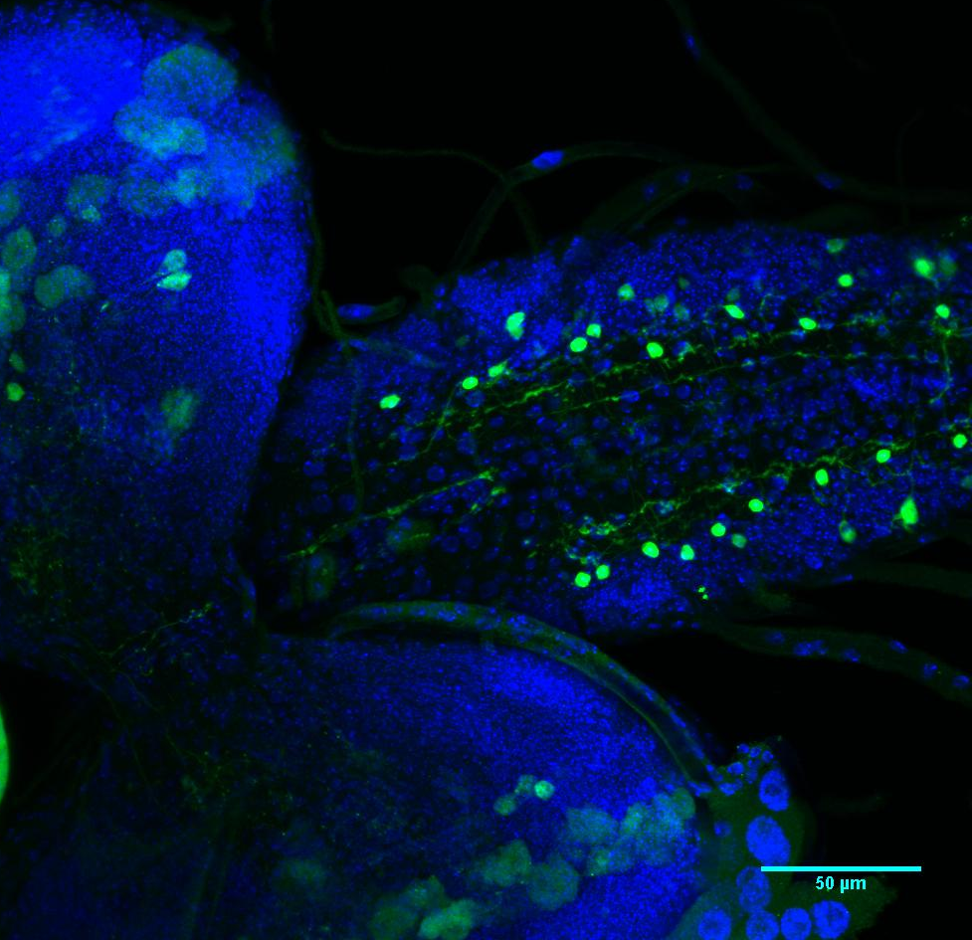
Figure 2.10. 3rd instar larval brain of progeny of EN line crossed to Notch transcriptional reporter gene [Su(H)]₃-lacZ. Hence the Eaat1-GAL4 is driving UAS-NICD which in turn should be over-expressing LacZ ; blue=DAPI, green=lacZ, z-projection of 10 slices, scale bar=50µm.

